# VH-TLA

# Lockheed 188A Electra

## Construction Number: 1061

**It was also registered as: N188LA; XW-PKA**

**History Of This Aircraft …**

The order for two Lockheed Electras was placed by Trans-Australia Airlines - October 10, 1958

First flown - May 19, 1959

This was the first Electra delivered with the uplilted engine mounts incorporated during construction

Entered onto the Australian Aircraft Register as VH-TLA - June 15, 1959

Registered to Australian National Airways Commission, Melbourne

It arrived at Melbourne (Essendon) on completion of the delivery flight - June 24, 1959

Delivery route: San Francisco - Honolulu - Canton Island - Nadi - Melbourne

Flight crew: Captains F. Fischer, J. Maloney, J. Hickey; Navigator H. Cast; Engineer A. Wright

It performed a flypast with the newly arrived Viscount VH-TVQ and Friendship VH-TFA before landing

The aircraft was named 'John Eyre'

Operated its first revenue service Melbourne (Essendon) - Sydney (Kingsford Smith) as TN534 - July 08, 1959

Set a speed record between Melbourne - Brisbane of 129 minutes (Captain W. O. James) - February 15, 1960

Departed Melbourne (Essendon) for Burbank for wing and engine mount modification - January 25, 1961

Ferry route: Melbourne - Nadi - Canton Island - Honolulu - Burbank

Flight crew: Captains R. B. Keig, I. A. F. Clarke, R. Lauchland; F/O D. W. R. Pummeroy; F/E R. C. Lane

Entered the Lockheed (LEAP) Program as LEAP #71 TAA-1 - January 27, 1961

LEAP modification completed - February 23, 1961

Departed Burbank on the ferry flight to Melbourne (Essendon) - February 23, 1961

Flight crew: Captains V. C. Austen, M. I. Fitzgerald, T. R. Bennet; F/O K. J. Purnell; F/E F. C. Storer

Set a speed record on Brisbane - Melbourne (Essendon) sector of 148 mins 30 seconds - March 13, 1961

Set a speed record on Melbourne - Sydney sector of 54 minutes (Captain G. J. White) - July 08, 1961

The aircraft was grounded by a Department of Civil Aviation order - July 24, 1964

This was the result of corrosion specks being found in the wing of TAA Electra VH-TLB

These specks had been misidentified as being wing cracks

This grounding order was lifted on the Australian Electra fleet - July 27, 1964

Operated its final revenue service Canberra - Sydney (Kingsford Smith) as TN406 - April 30, 1971

Ferried Sydney (Kingsford Smith) - Brisbane for storage (Captain Humphries) as TN2890 - April 30, 1971

The aircraft had flown 34,063 hours with 26,925 cycles

Test flown at Brisbane (Captain S. Arnold, R. Hickey; F/E R. Verity) - September 15, 1971

Test flown at Brisbane before being ferried Brisbane - Melbourne direct in 2 hrs 35 mins - February 07, 1972

Flight crew: Captains S. Arnold, A. Hofman; F/E R. Verity

Sold to Concare Aircraft Leasing - March 12, 1972

Entered onto the United States Aircraft Register as N188LA - March 1972

Test flown at Melbourne (Tullamarine) as VH-TLA / N188LA - March 26, 1972

Cancelled from the Australian Aircraft Register - April 05, 1972

Departed Melbourne (Tullamarine) on the ferry flight to the United States - April 12, 1972

Ferry route: Melbourne - Port Moresby - Wake Island - Hilo - Burbank

Lease / purchased from Concare Aircraft Leasing by Transair Corp - 1972

Leased to Royal Air Lao - May 1972

Entered onto the Laotian Aircraft Register as XW-PKA - 1972

The aircraft was named 'Tiao Anou'

It arrived at Vientiane on the ferry flight from Miami, Florida - July 18, 1972

Grounded and used as a source of parts to keep Electra ‘XW-PKB’ airworthy - December 1973

Fearing seizure by the new Lao Government work commenced to return it to airworthy status - August 1974

Parts were sourced from ‘XW-PKB’ which was in Hong Kong for overhaul

Departed Vientiane for Singapore (Seletar) for overhaul by Lockheed - September 20, 1974

Flight crew: Captains A. Ogle; F/O A. Adolph; F/E W. Dettori; Mechanic P. Dreith

The aircraft arrived at Seletar after an exciting ferry flight - September 21, 1974

This aircraft did not fly again

Sold to American Jet Industies along with Electra ‘XW-PKB’ - 1975

Entered onto the United States Aircraft Register as N188LA - January 13, 1976

Registered to American Jet Industries Inc

Scrapped at Singapore (Seletar- 1976

Cancelled from the United States Aircraft Register as 'destroyed' - March 16, 1976

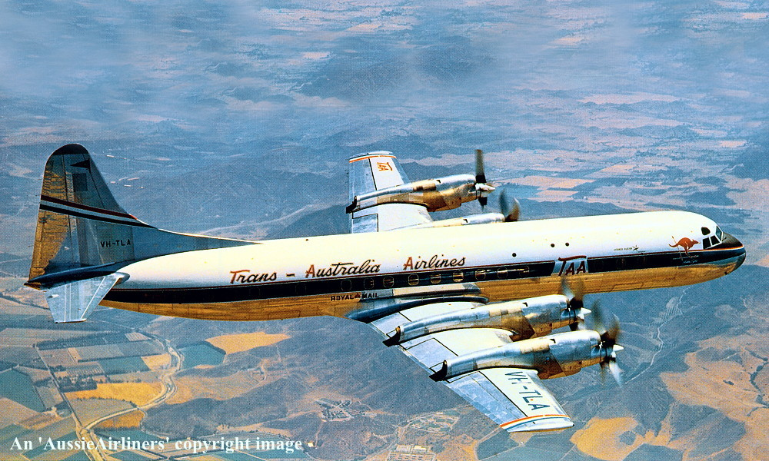

**VH-TLA. ‘John Eyre’ - somewhere over California - June 1959.**

**Original livery**

**R. N. Smith Collection (#1808-508)**

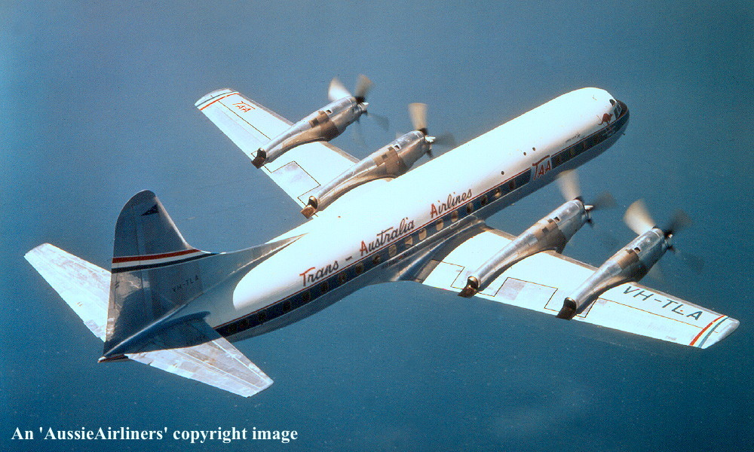

**VH-TLA. ‘John Eyre’ - somewhere over California - June 1959.**

**Original livery**

**R. N. Smith Collection (#1808-183)**

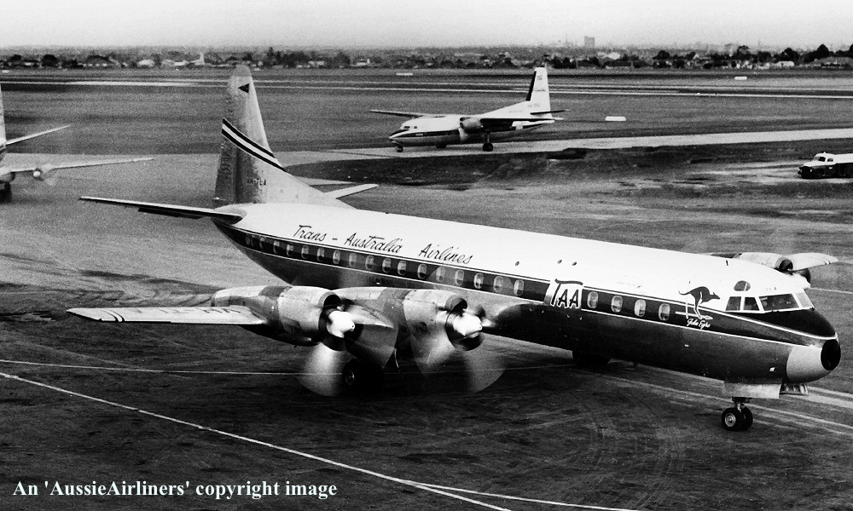

**VH-TLA. ‘John Eyre’ - Melbourne Essendon Airport - June 24, 1959.**

**Original livery**

**R. N. Smith Collection (#1808-526)**

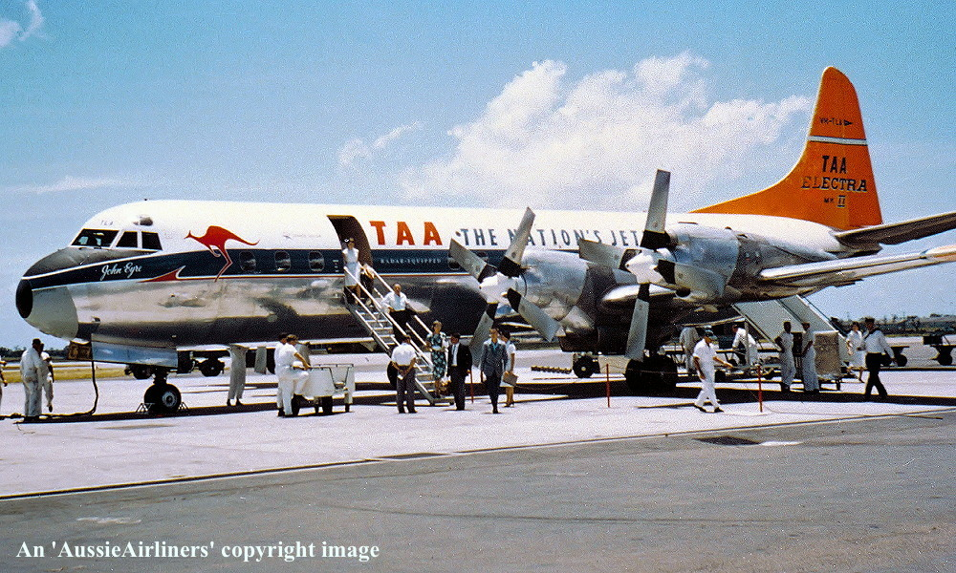

**VH-TLA. ‘John Eyre’ - Brisbane Archerfield Airport - circa 1961.**

**‘Dayglow tail’ livery**

**R. N. Smith Collection (#1808-932)**

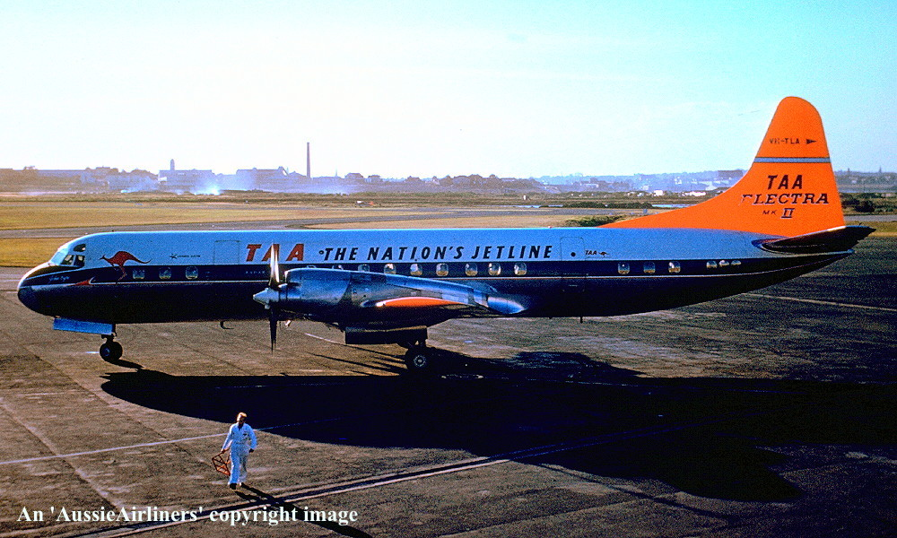

**VH-TLA. ‘John Eyre’ - Sydney Kingsford Smith Airport - June 1962.**

**‘Dayglow tail’ livery**

**R. N. Smith Collection (#1808-184)**

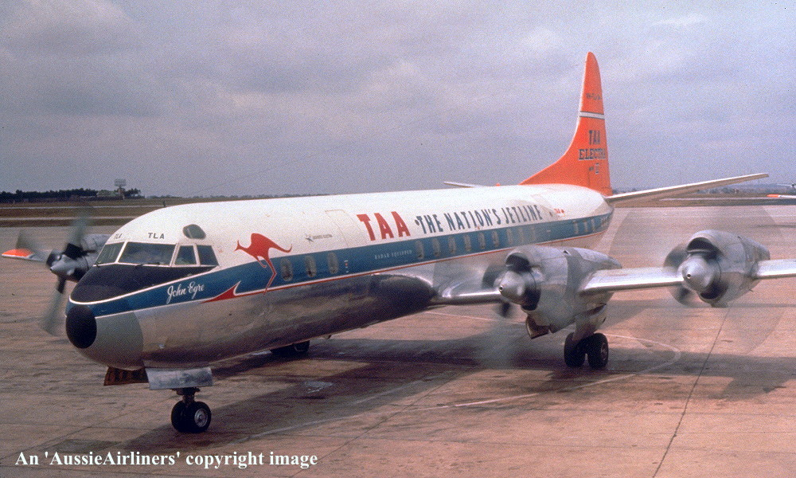

**VH-TLA. ‘John Eyre’ - Brisbane Archerfield Airport - July 1962.**

**‘Dayglow tail’ livery**

**R. N. Smith Collection (#1808-186)**

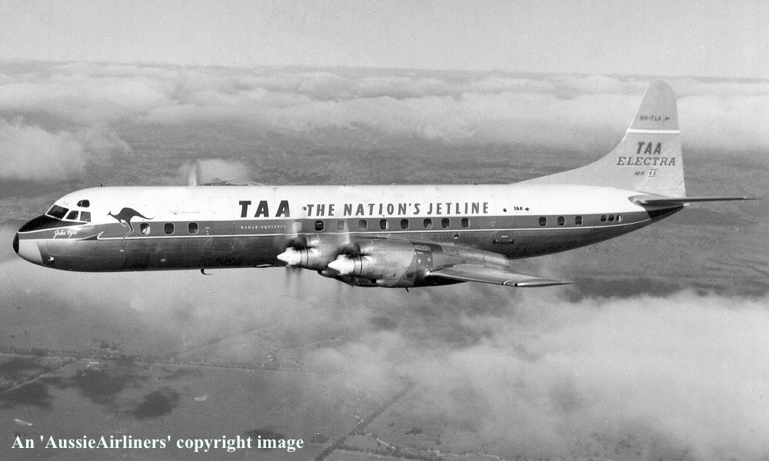

**VH-TLA. ‘John Eyre’ - Unknown location - July 1962.**

**‘Dayglow tail’ livery**

**R. N. Smith Collection (#1808-344)**

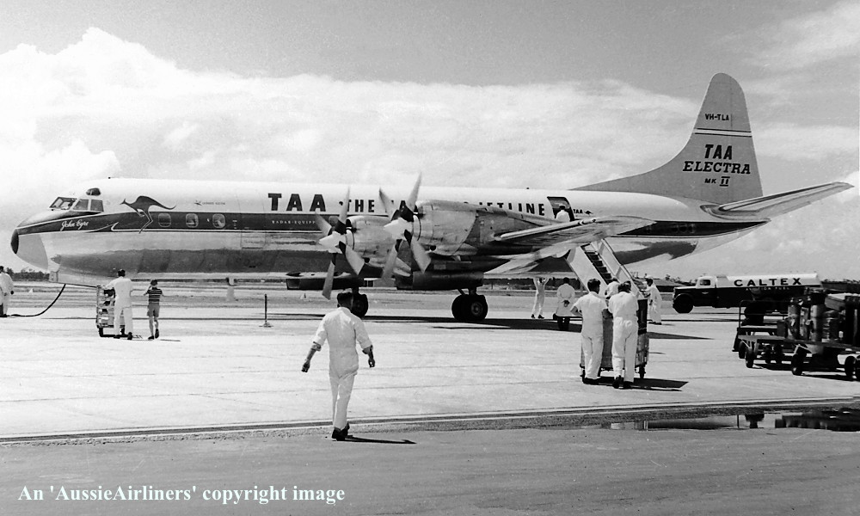

**VH-TLA. ‘John Eyre’ - Brisbane Archerfield Airport - circa 1962.**

**‘Dayglow tail’ livery**

**R. N. Smith Collection (#1808-565)**

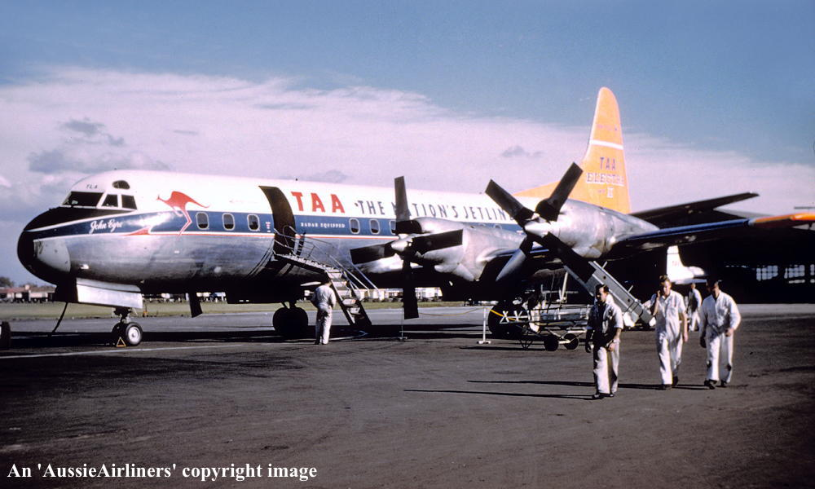

**VH-TLA. ‘John Eyre’ - Melbourne Essendon Airport - circa 1962.**

**‘Dayglow tail’ livery**

**R. N. Smith Collection (#1808-391)**

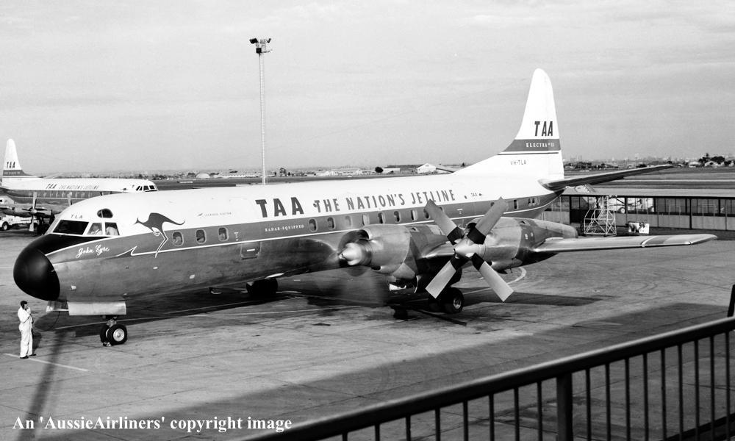

**VH-TLA. ‘John Eyre’ - Melbourne Essendon Airport - August 24, 1963.**

**‘White tail’ livery**

**R. N. Smith Collection (#1808-778)**

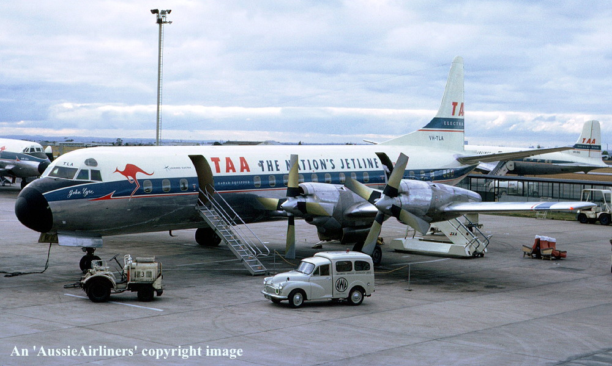

**VH-TLA. ‘John Eyre’ - Melbourne Essendon Airport - July 1966.**

**‘White tail’ livery**

**R. N. Smith Collection (#1808-188)**

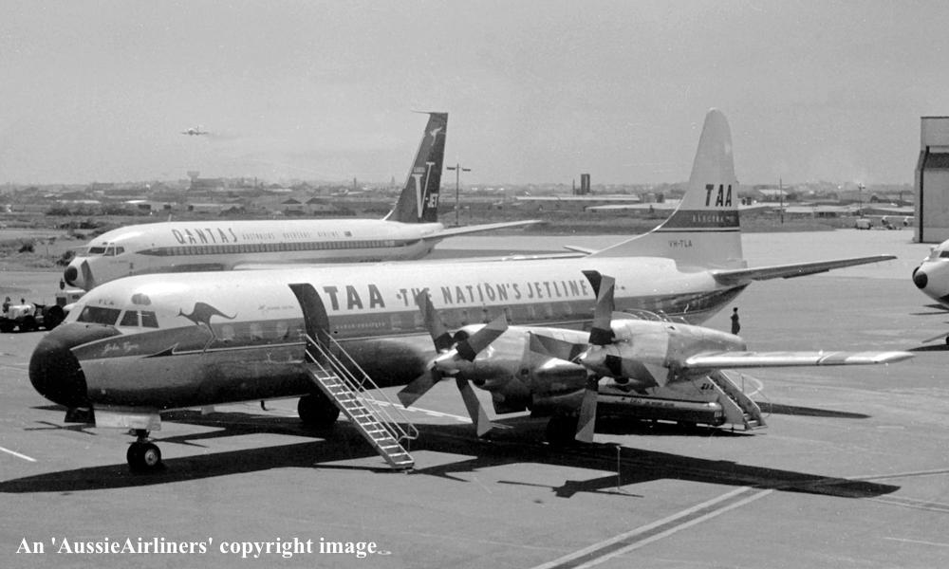

**VH-TLA. ‘John Eyre’ - Sydney Kingsford Smith Airport - date unknown.**

**‘White tail’ livery**

**J. Hopton (#1808-633)**

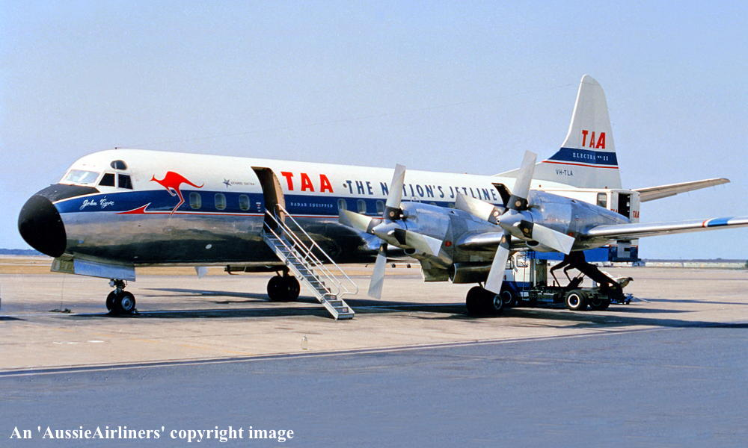

**VH-TLA. ‘John Eyre’ - Brisbane Archerfield Airport - date unknown.**

**‘White tail’ livery**

**R. N. Smith Collection (#1808-775)**

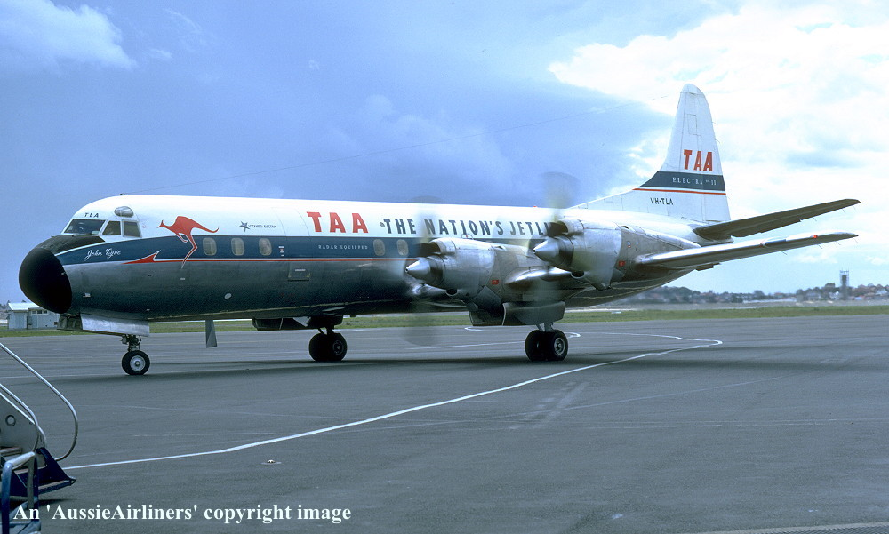

**VH-TLA. ‘John Eyre’ - Sydney Kingsford Smith Airport - December 29, 1966.**

**‘White tail’ livery**

**R. N. Smith (#1808-189)**

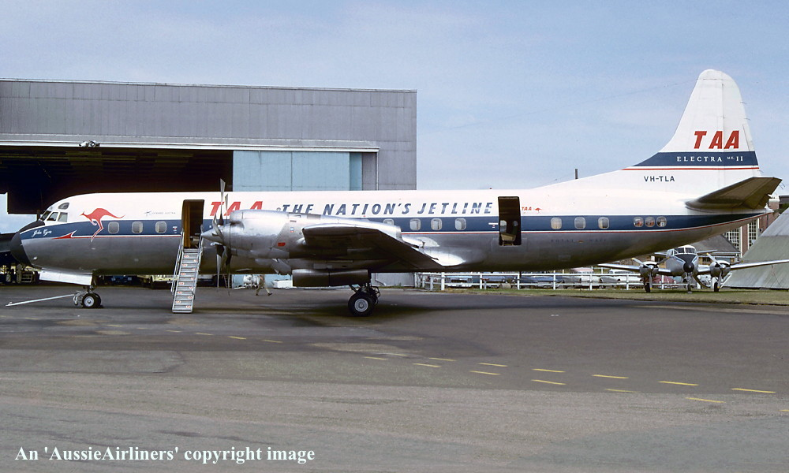

**VH-TLA. ‘John Eyre’ - Brisbane Archerfield Airport - February 1967.**

**‘White tail’ livery**

**R. N. Smith Collection (#1808-509)**

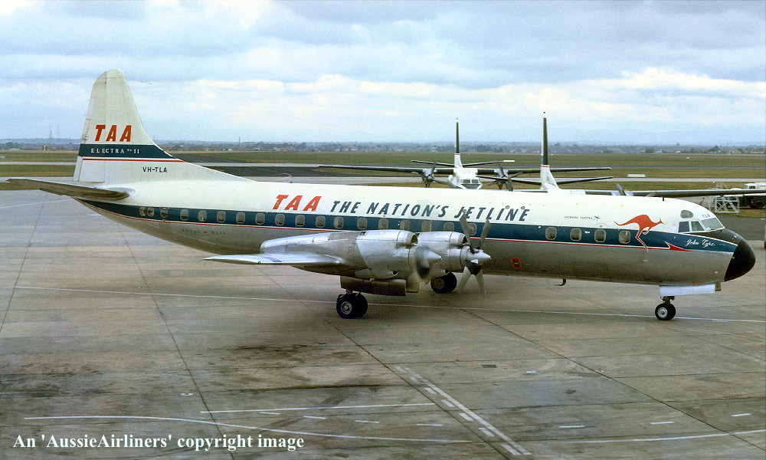

**VH-TLA. ‘John Eyre’ - Melbourne Essendon Airport - June 1967.**

**‘White tail’ livery**

**J. Hopton (#1808-505)**

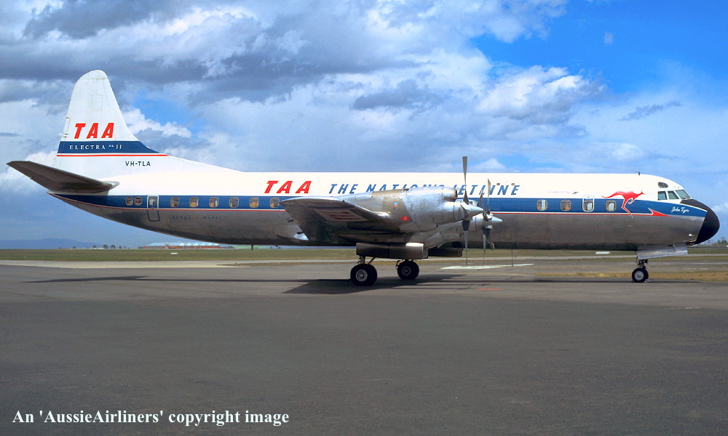

**VH-TLA. ‘John Eyre’ - Melbourne Essendon Airport - January 17, 1968.**

**‘White tail’ livery**

**R. N. Smith Collection (#1808-560)**

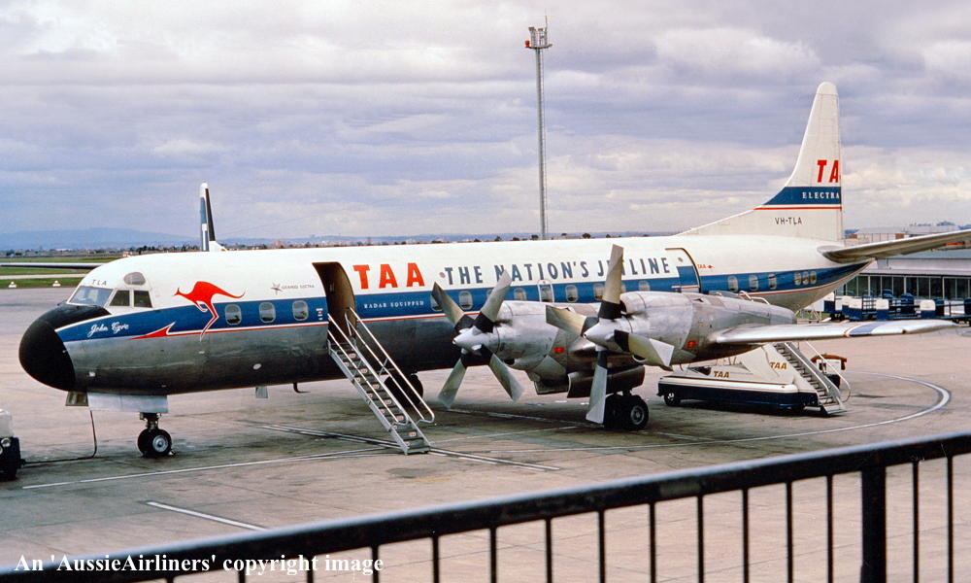

**VH-TLA. ‘John Eyre’ - Melbourne Essendon Airport - date unknown.**

**‘White tail’ livery**

**R. N. Smith Collection (#1808-776)**

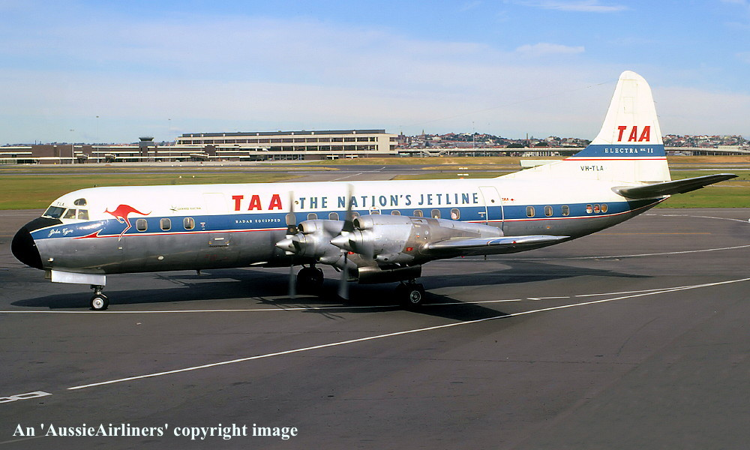

**VH-TLA. ‘John Eyre’ - Sydney Kingsford Smith Airport - April 14, 1970.**

**‘White tail’ livery**

**R. N. Smith (#1808-880)**

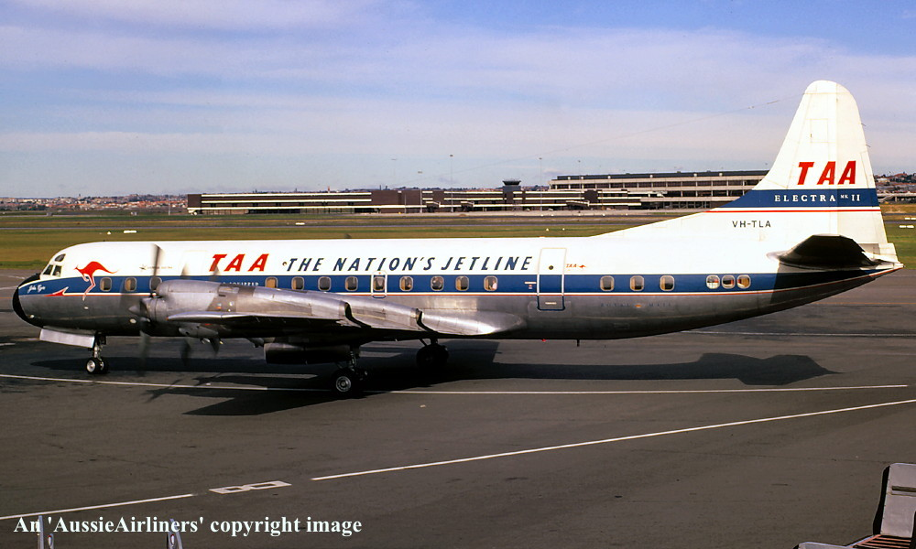

**VH-TLA. ‘John Eyre’ - Sydney Kingsford Smith Airport – April 14, 1970.**

**‘White tail’ livery**

**R. N. Smith (#1808-566)**

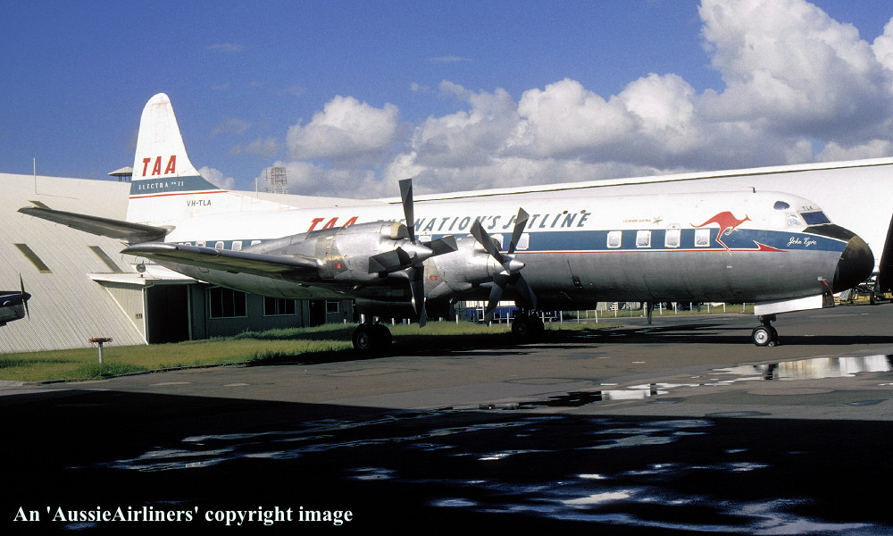

**VH-TLA. ‘John Eyre’ - Brisbane Archerfield Airport - December 1971.**

**‘White tail’ livery**

**E. D. Daw (#1808-195)**

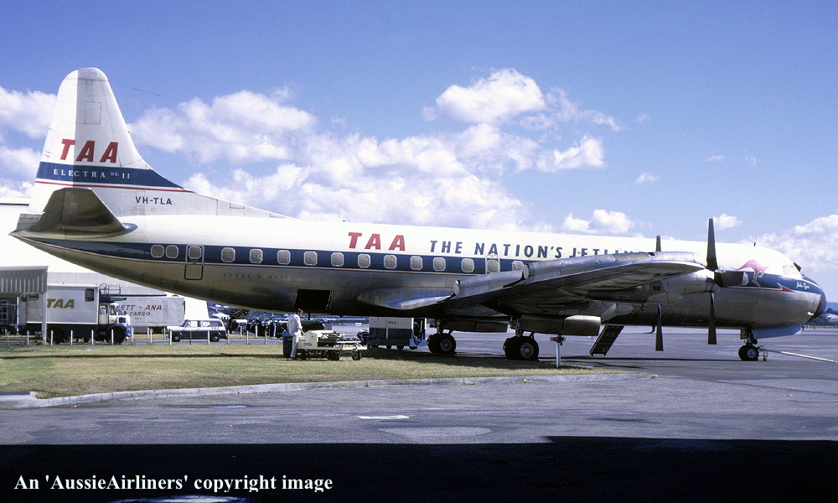

**VH-TLA. ‘John Eyre’ - Brisbane Archerfield Airport - December 1971.**

**‘White tail’ livery**

**E. D. Daw (#1808-194)**

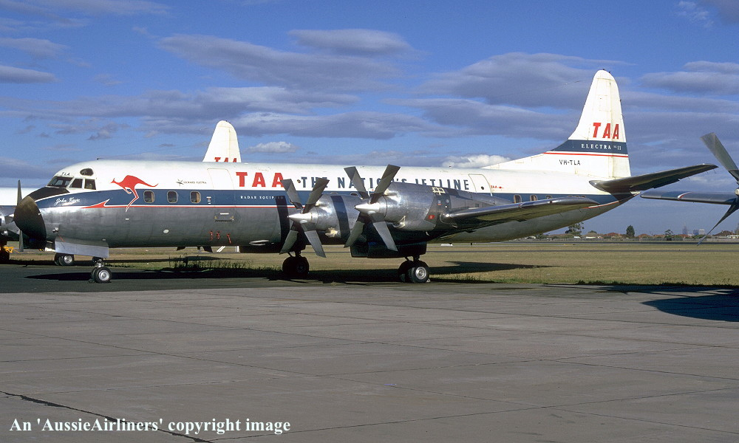

**VH-TLA. ‘John Eyre’ - Melbourne Essendon Airport - February 1972.**

**‘White tail’ livery**

**R. N. Smith Collection (#1808-191)**

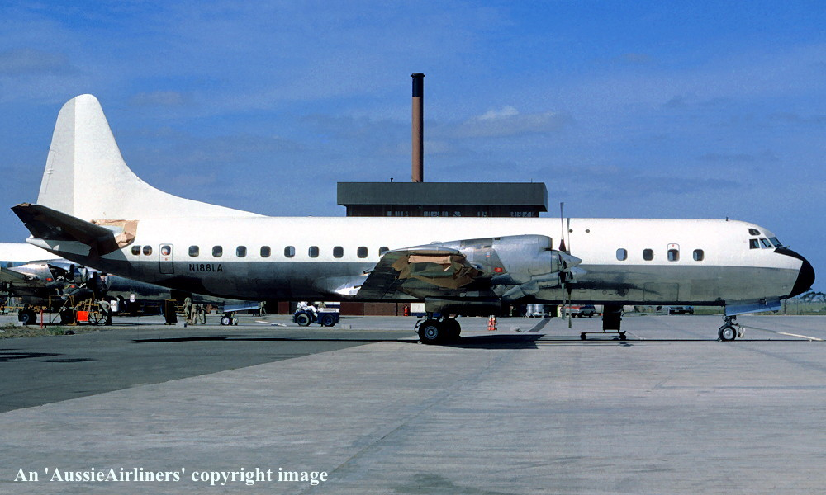

**N188LA. Concare Aircraft Leasing - Melbourne Tullamarine Airport - March 1972.**

**‘All-white’ livery - no titles**

**G. Bennett (#1808-737)**

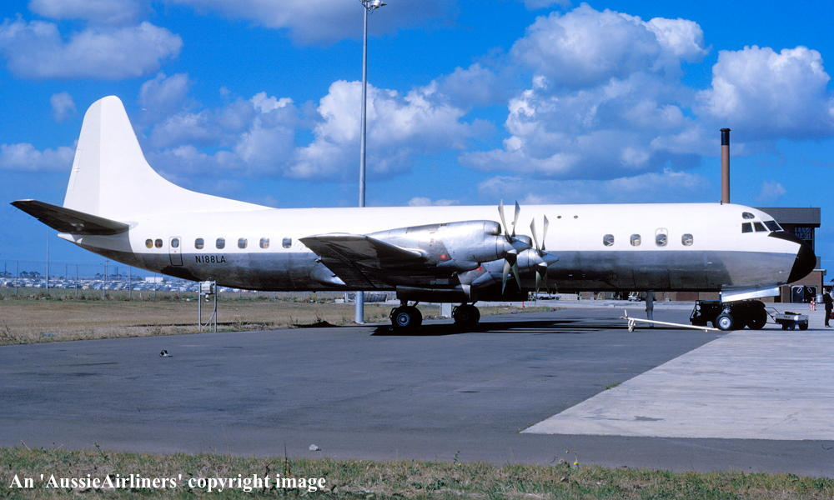

**N188LA. Concare Aircraft Leasing - Melbourne Tullamarine Airport - April 1972.**

**‘All-white’ livery - no titles**

**G. Bennett (#1808-202)**

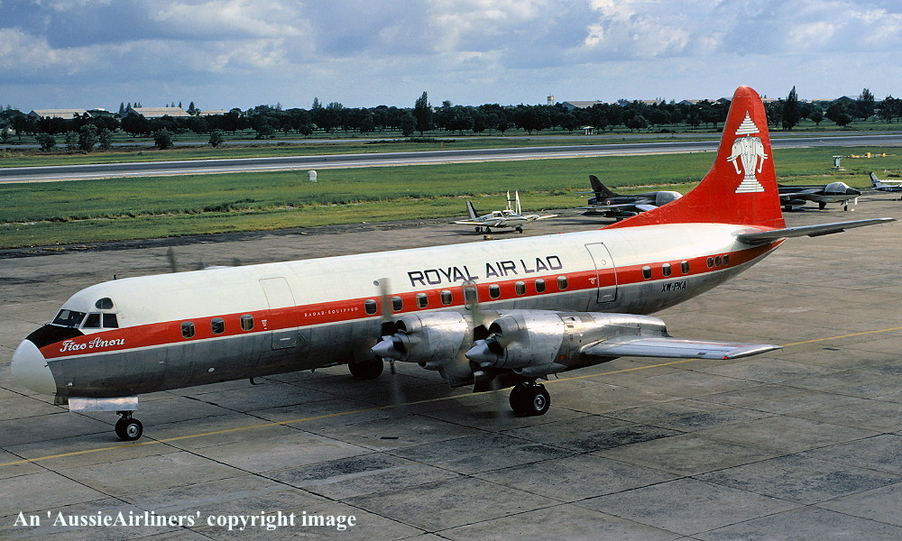

**XW-PKA. Royal Air Lao - ‘Tiao Anou’ - Singapore Seletar Airport - November 1972.**

**Standard livery**

**R. N. Smith Collection (#1808-547)**

## An Important Message …

**This document has been prepared by Robert N. Smith, creator / owner of ‘AussieAirliners’ and has been donated to the HARS Aviation Museum to ensure that this valuable resource is preserved for the enjoyment of future aviation enthusiasts and other interested persons.**

**While every effort has been made to ensure the accuracy of the information contained within this document, the writer makes no representation as to the accuracy of said information. This information has been obtained from a wide variety of sources, including data that has been posted in the public domain. The images appearing within this document are covered by International Copyright Laws. No image can be downloaded for reproduction or republishing in part or whole, on or in any form of media, including blogs, other websites, digital image file-sharing sites and all forms of social media sites unless prior approval has been obtained from the HARS Aviation Museum. Images have been watermarked with the ‘AussieAirliners’ logo or the photographer’s name for protection.**

**Any image that has been credited to the ‘Qantas Heritage Collection’ cannot be reproduced / used in any way unless written permission has been obtained from Qantas Airways. This can be facilitated by contacting the Manager, Qantas Heritage Collection at Sydney Airport.**